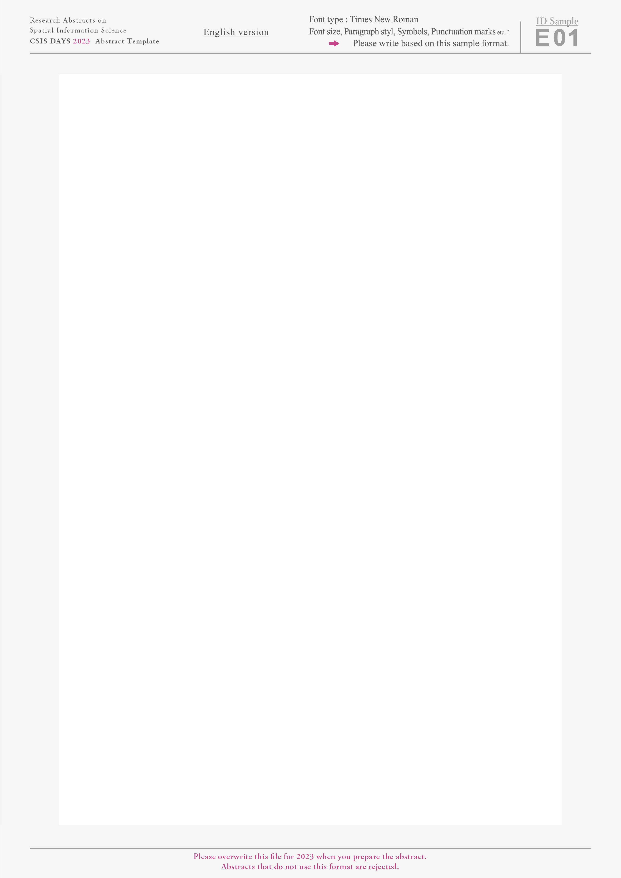**­­ Quantifying the Pedestrian Distribution of Special Events based on Pedestrian Count Data**

A. N. Author 1 and A. N. Author 2

1 Department, University, 2 Department, University

mail-address@xxx.yyy

https://website-url/

**1 Introduction:** This study aims to develop the method to quantify pedestrian distribution regarding not only quantity but also spatial and temporal distribution with the convenient calculation based on pedestrian count data to make it possible to incorporate pedestrian distribution in-to special event planning such as sports events and town festivals.

**2 Method:** This study used five years (2014-2018) of pedestrian count data obtained from Commerce and Tourism Division, Toyota City, Japan. Toyota city operates 21 count points. Because several count points were installed in 2017, this study employed data from 13 count points. The number of pedestrians that pass below is counted every hour from 5:00 am to 12:00 pm. This study suggests three indexes, quantity, spatial and temporal inequality for each day. First, quantity index ($Q_{i}$) is calculated by the sum of pedestrian counts for all points and times. Second, spatial inequality index ($S_{i}$) is defined by the Gini index using the sum of pedestrian counts for all times. Third, temporal inequality ($H_{i}$)index is defined by the Gini index using the sum of pedestrian count for all points. This index has a value between 0 to 1. As spatial index higher, distribution of the pedestrian counts is skewed to specific points. Table 1 shows the number of target events.

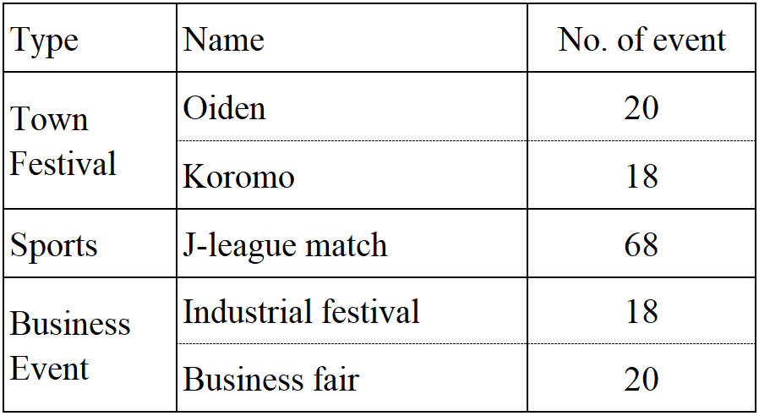**3 Result:** Figure 1 shows the results of three kinds of special events have strong effects on the vitality of Toyota city: J-league match (soccer), Oiden festival, and Koromo festival. Oiden festival shows the largest value of $Q_{i}$ and the smaller value of $S_{i}$. It indicates that victors of Oiden festival tend to walk around wider area compared to the other two events. Koromo festival and J-League math show a significant difference in $S_{i}$ even though values of $Q_{i}$ are similar. It implies that visitors for J-League tends to concentrate on the way to Toyota stadium.

**Figure 1:** Results of three events for five years in Toyota

**Table 1:** Number of events

This study developed the method to quantify pedestrian with three in-dexes: Quantity, spatial and temporal inequality. Our results show that three indexes can capture pedestrian distribution conveniently and can contribute to monitoring the effects of special events on the vitality of the city.

**4 Data:**

Pedestrian count data (2008~2018), Commerce and Tourism Division, Toyota City

Zmap TOWN II 2016, Zenrin

**5 Acknowledgments：**This study was supported by Joint Research Program No. 123 at CSIS, UTokyo.

**6 Reference：**

Ermagun, A., Lindsey, G., & Loh, T. H. (2018). Urban trails and demand response to weather variations. *Transportation Research Part D: Transport and Environment*, 63, 404–420.

Olfert, C., Poapst, R., & Montufar, J. (2018). Incorporating the effect of special events into continuous count site selection for pedestrian traffic. *Transportation Research Record*, 2672(43), 65–74.